Teaching Aid for ADE Report

**For B.E 3rd Semester**

## GROUP NO: 5

**:..............................................................CSE.......................................................................................................................................................................................................................................................................................................................................................................**

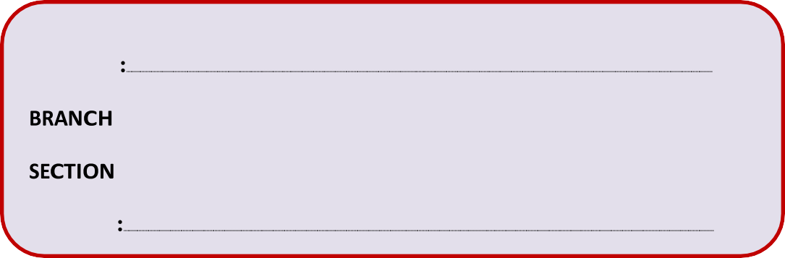

**1RN20CS - 009, 009, 012, 010, 016, 042, 006, 024, 027, 029, 050, 055**

## USN’s

**:............................................................A......................................................................................................................................................................................................................................................................................................................................................................**

**VISION AND MISSION OF INSTITUTION**

# Vision

**Building RNSIT into a World Class Institution**

# Mission

## To impart high quality education in Engineering, Technology and Management with a Difference, Enabling Students to Excel in their Career by

1. Attracting quality Students and preparing them with a strong foundation in fundamentals so as to achieve distinctions in various walks of life leading to outstanding contributions.
2. Imparting value based, need based, choice based and skill based professional education to the aspiring youth and carving them into disciplined, World class Professionals with social responsibility.
3. Promoting excellence in Teaching, Research and Consultancy that galvanizes academic consciousness among Faculty and Students.
4. Exposing Students to emerging frontiers of knowledge in various domains and make them suitable for Industry, Entrepreneurship, Higher studies, and Research & Development.
5. Providing freedom of action and choice for all the Stake holders with better visibility.

**VISION AND MISSION OF CSE DEPARTMENT**

# Vision

**Preparing better computer professionals for a real world**

# Mission

**The Department of Computer Science and Engineering will make every effort to promote an intellectual and an ethical environment in which the strengths and skills of Computer Professionals will flourish by**

1. Imparting Solid foundations and Applied aspects in both Computer Science Theory and Programming practices.
2. Providing Training and encouraging R&D and Consultancy Services in frontier areas of Computer Science with a Global outlook.
3. Fostering the highest ideals of Ethics, Values and creating Awareness on the role of Computing in Global Environment.
4. Educating and preparing the graduates, highly Sought-after, Productive, and Well- respected for their work culture.
5. Supporting and inducing Lifelong Learning practice

# Group member details:

|  |  |  |
| --- | --- | --- |
| **SL. NO.** | **NAME** | **USN** |
| 1 | Aman Kumar | 1RN20CS016 |
| 2 | Aradhya Pandey | 1RN20CS024 |
| 3 | Aditya Anand | 1RN20CS009 |
| 4 | Aditya Sudhanshu | 1RN20CS012 |
| 5 | Ayush Dixit | 1RN20CS029 |
| 6 | Adarsh | 1RN20CS006 |
| 7 | Awnish Kumar | 1RN20CS027 |
| 8 | Aditya Bohra | 1RN20CS010 |
| 9 | Harsh Anand | 1RN20CS050 |
| 10 | Irfan Farooq | 1RN20CS055 |
| 11 | Divyansh Tiwari | 1RN20CS042 |

.

# Title: Mechanical Binary Counter

**Description:**

**Introduction:**

A binary counter is a hardware circuit that is made out of a series of flip-flops. The output of one flip-flop is sent to the input of the next flip-flop in the series. A binary counter can be either asynchronous or synchronous, depending on how the flip-flops are connected together.

**AIM:**

To design a mechanical binary up counter to better understand how the binary bits change.

# Model Screenshot:

|  |  |
| --- | --- |
| Decimal | Binary |
| 0 | 0000 |
| 1 | 0001 |
| 2 | 0010 |
| 3 | 0011 |
| 4 | 0100 |
| 5 | 0101 |
| 6 | 0110 |
| 7 | 0111 |
| 8 | 1000 |
| 9 | 1001 |
| 10 | 1010 |
| 11 | 1011 |
| 12 | 1100 |
| 13 | 1101 |
| 14 | 1110 |
| 15 | 1111 |